AMAZON FINANCIAL ANALYSIS
Student’s Name:
Institution Affiliation:
AMAZON FINANCIAL ANALYSIS

-1—Background and Industry
The background of the study is based on company financial analysis which enables the evaluation of firm performance as well as the subsequent comparison of the company financial performance over time. The financial performance can also be compared against other companies in the various industries therefore enabling the determination of the firm’s position in the market or industry. The basis for the financial analysis of AMAZON in this case is the deduction of the firm’s ability to be able to able to be continual and profitable over time which is consistent with the accounting principle of going concern for firms. More specific analysis has been done through a ratio analysis conducted for the company financial ratios as indicators for the company current position in terms of financial health which is important in the sense that it subsequently provides decision makers with the correct information on what to do in present time and in the future in order to improve and optimize the company performance. Recommendations have been provided based on the company analysis and the various important points that need to be focused on to improve the company financial position.
-2— Common size analysis (15% of the project grade). You can find the common size financial statements for the company for the last 3-5 years on www.morningstar.com. Type the stock symbol in the Quotes window to get into the company’s page. Scroll down and click on All Financial Data. Switch View from “$” to “%”.
Create a table that contains the most significant common size financial performance results for the last 3-5 years for THE COMPANY and for the last year for the major competitor. Present the table with this information in your report.

Common sized financial analysis is based on analyzing the company financials whereby every item in the financials is viewed in terms of percentage of sales in the income statement and a percentage of total assets in the balance sheet.
Income statement analysis (3 to 5 yeas)
Revenue is 1% throughout for the 5 years from2013 to 2017as function of common size analysis. The cost of sales increased from 84.30% in 2013 to 75.05% in 2017 which means there a subsequent increase in the overall amount of sales as well as the increase in gross profit for the same period. The gross profit increased from 15.7 % in 2013 to 24.95 % from 2014 to 2017 which represents an increase of roughly 9% for the 5 years which explains to a positive financial performance for the firm during that period. The operating expenses for Amazon increased from 14.7% of the overall sales in 2013 to 20.07% of the overall sales in 2017 probably due to the expansion and subsequent increase in the overall fixed and variable overheads for the firm. The income before taxes increased from 0.68 % in 2014 to 4.43% of the overall revenue in 2018 which basically shows that the income before taxes increased by about 4% as a fraction of the overall sales of the firm during the 5-year period thus indicating that the firm was doing quite well. Income tax provision for Amazon has been shown to increase from 0.22% in 2014 to 0.40 % in 2018 which represents an increase of 0.24% of the overall provision for income tax. (Morninng Star Inc, 2019)
The higher the company income before taxes the higher the corporate tax be paid given the standard corporation tax rate which by extension means the firm had a higher overall income due to increased performance. However, taxes have different treatments by companies as some firms can opt to defer the taxes through the creation of a tax liability to be paid in the future by the firm depending on the circumstances faced by the firm. The flip side is also possible through the payment of more taxes which ideally create a “tax asset” which can be claimed by the firm in the future to offset some of the taxes for that period. This observation explains the various percentages of the corporate tax charged which differ substantially and have a considerable variation. The Net income for Amazon increased from 0.37% to 4.03 from 2013 to 2017 which is essentially representative of an increase in the net income by 3.66%.This observation illustrates that the firm has done well over the last 5 year period. (Morninng Star Inc, 2019)
Balance sheet
The current assets for Amazon decreased from 61.32 % to 45.84% with the cash percentage also decreasing from 30.99% to 23.60% from 2013 to 2017, the 5-year period that ensued which means the firm had a lower overall ability to meet its short term obligations. The property plant and equipment increased from 27.26% as a percentage of total assets to 37.21% of the total assets from 2013 to 2017 as a proportion of total assets. The current liabilities decreased from 57.22% to 44.88% from 2013 to 2017 while the non-current liabilities increased from 18.51% to 34.82% which suggest that Amazon had a higher level of long term obligations and lower level of current short term obligations. However, the firm had a higher overall value of total liabilities that increased from 75.73% to 78.90% for the same 5-year period. The stockholder equity however decreased from 24.27% to 21.20% from 2013 to 2017 as a percentage of total assets. (Morning Star, 2019)

-3— Trend analysis
Analyze the financial trends over 5 years of Revenue, net income, and any other of the most significant financial performance results of your choice. To present your findings, you will use the table(s) and/or graphs.
Revenue increased from $74.4 B to $177.9 B from 2013 to 2017 end of the financial year period showing quite a huge increase in the overall revenue. The net income increased from$ 0.274 B to $8.903 B for the same 5-year period demonstrating quite an improvement of the firm performance which is represented by a multiple of 3.66 % of the total sales.
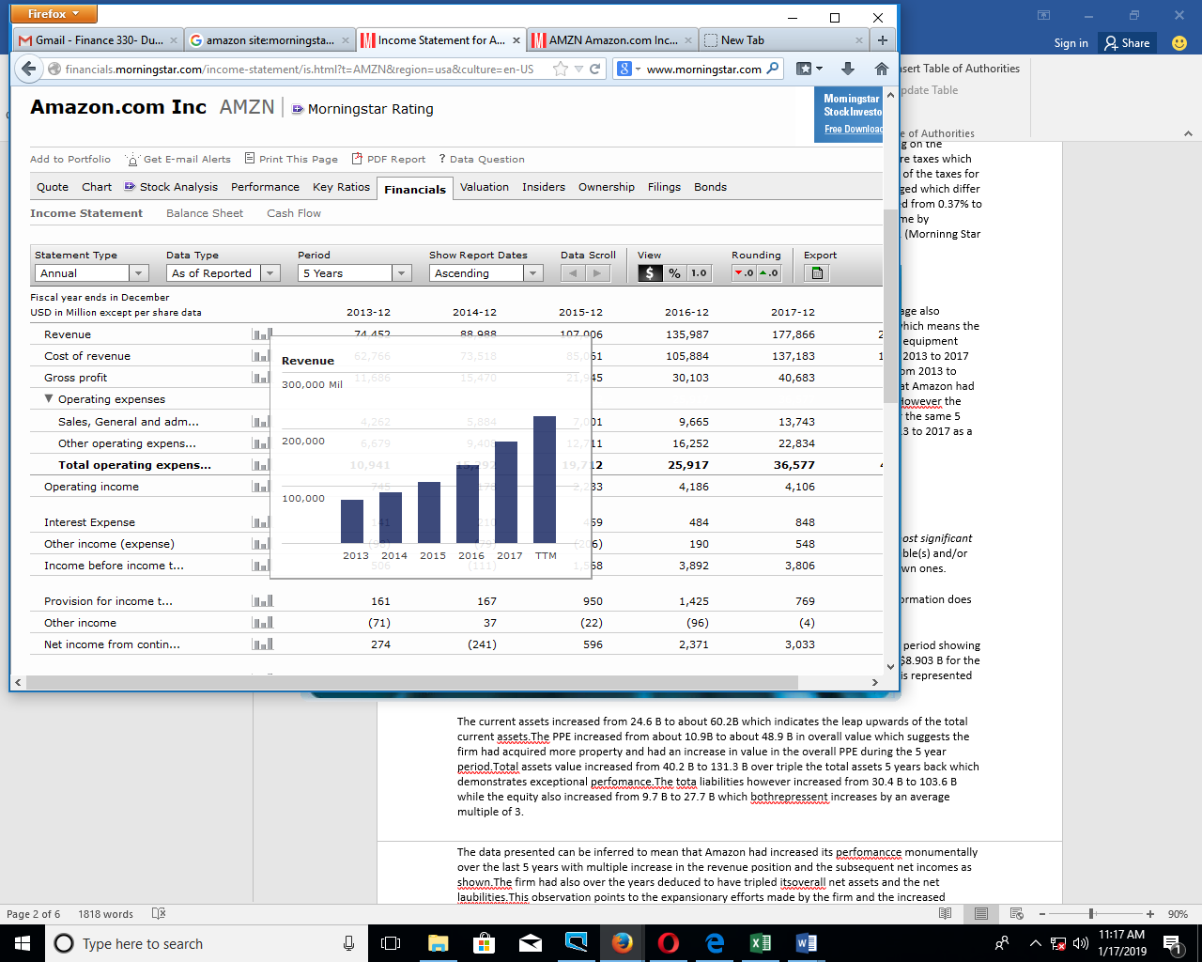
Figure : Screenshot showing the revenue graph for the firm (Morninng Star Inc, 2019)
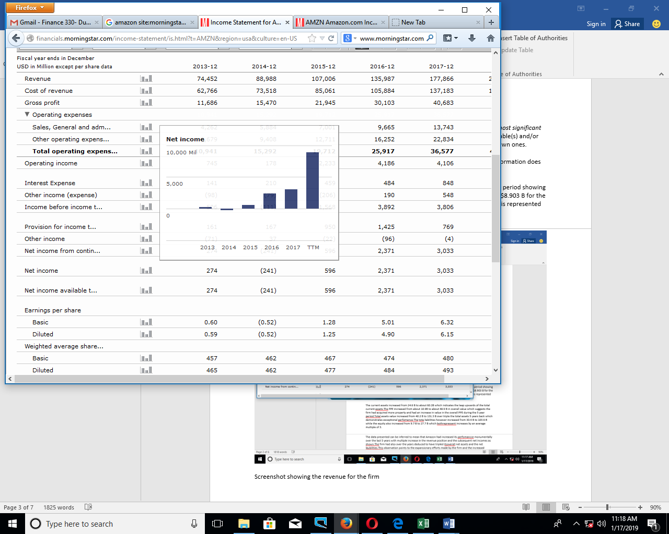
Figure : Screenshot showing the net income bar graph (Morninng Star Inc, 2019)

The current assets increased from $24.6 B to about $60.2B which indicates the leap upwards of the total current assets. The PPE increased from about $10.9B to about $48.9 B in overall value which suggests the firm had acquired more property and had an increase in value in the overall PPE during the 5-year period. Total assets value increased from $40.2 B to $131.3 B over triple the total assets 5 years back which demonstrates exceptional performance. The total liabilities however increased from $30.4 B to $103.6 B while the equity also increased from $9.7 B to $27.7 B which both represent increases by an average multiple of 3. (Morning Star, 2019)
The data presented can be inferred to mean that Amazon had increased its performance monumentally over the last 5 years with multiple increase in the revenue position and the subsequent net incomes as shown. The firm had also over the years deduced to have tripled its overall net assets and the net liabilities. This observation points to the expansionary efforts made by the firm and the increased foothold adopted by the firm to be one of the most valuable companies in North America. The information provided also points to the fact that the firm has been strategic in investing and expansion which has been done on a leveraged position which explains the increase in the total liabilities due to increased non-current liabilities. The firm has basically cut its overall costs by investing through credit facilities which are subject to tax deductions resulting to higher overall margins or net incomes.
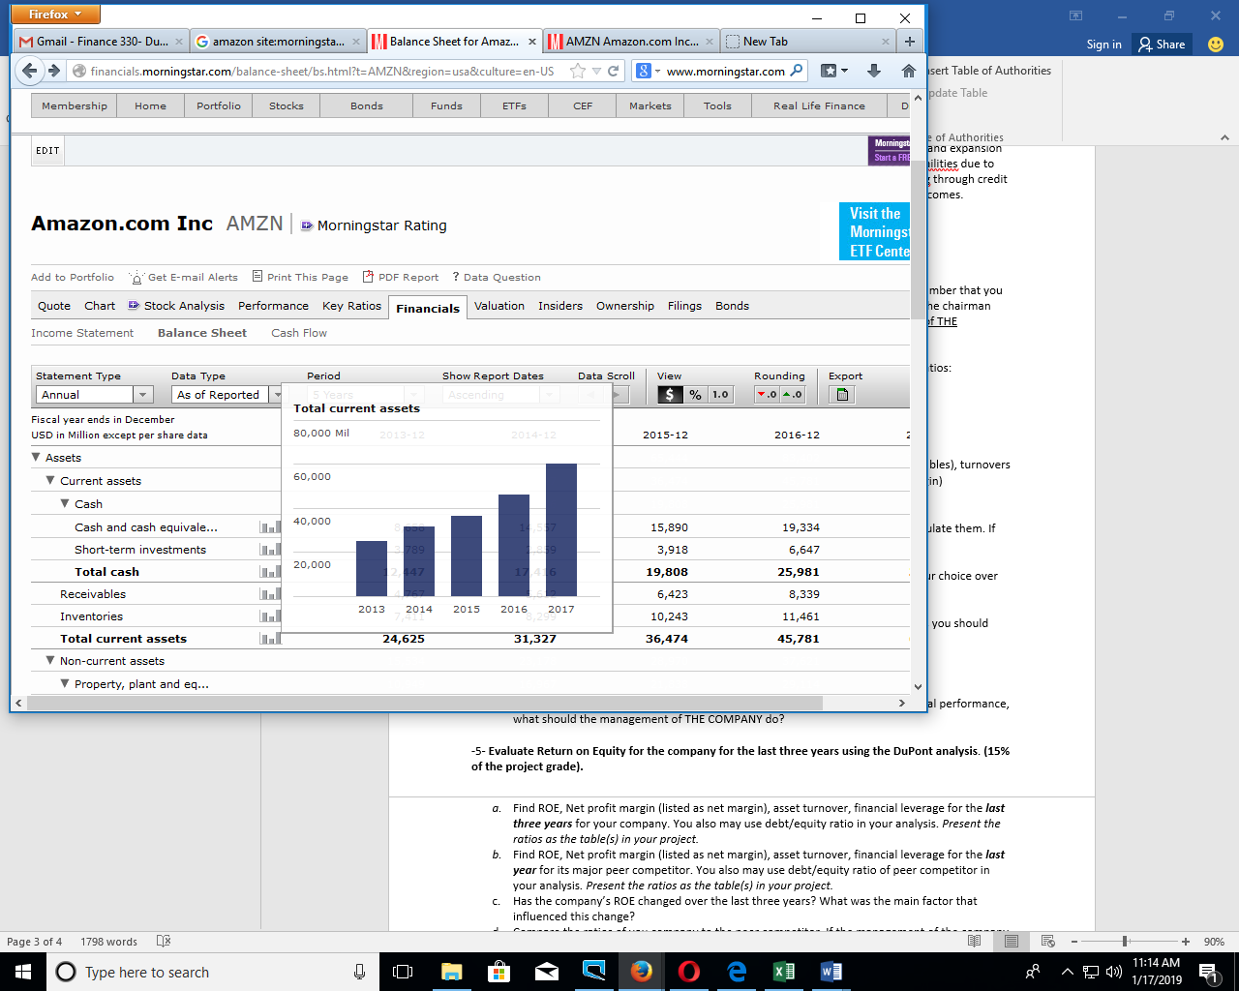
Screenshot showing the current assets
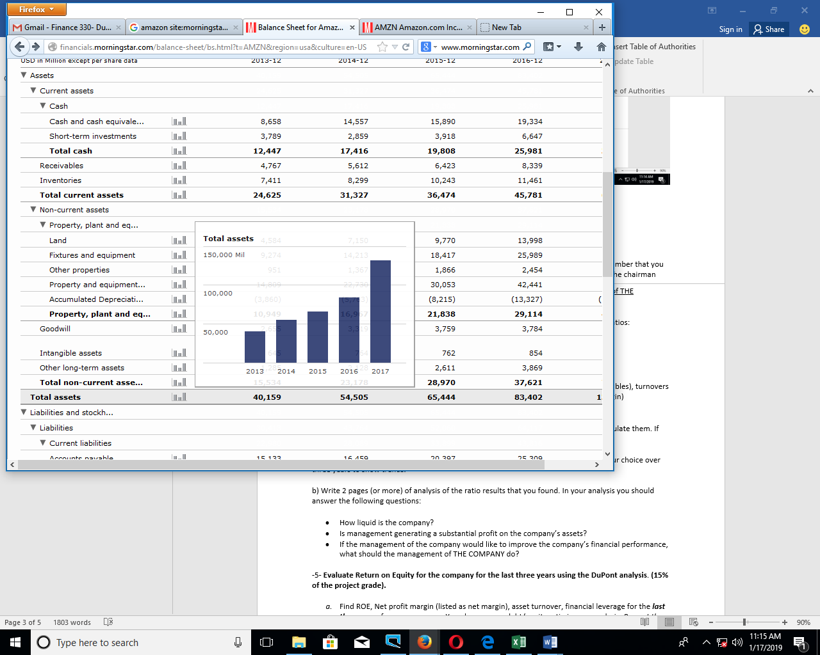screenshots showing the total assets
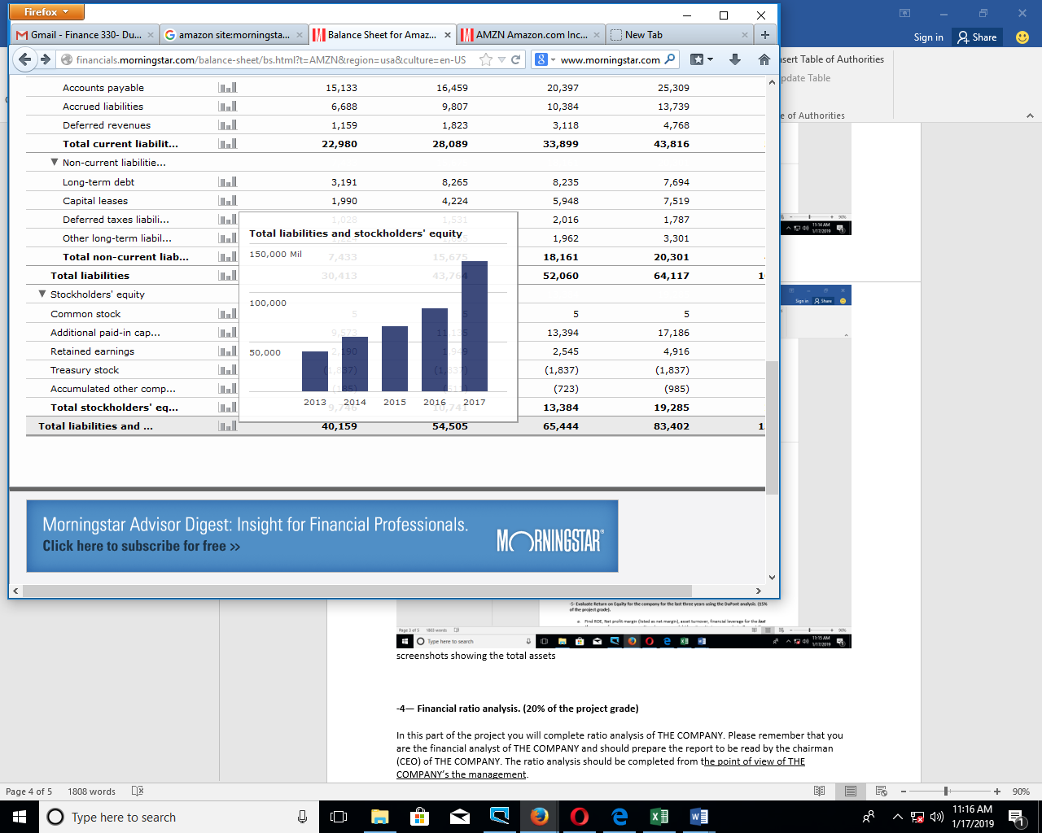
Figure : Screenshot showing the total liabilities and equity for the firm. (Morning Star, 2019)
-4— Financial ratio analysis.
In this part of the project you will complete ratio analysis of THE COMPANY. Please remember that you are the financial analyst of THE COMPANY and should prepare the report to be read by the chairman (CEO) of THE COMPANY. The ratio analysis should be completed from the point of view of THE COMPANY’s the management.
- Present the ratios as the table(s) in your project. Create graphs for some ratios on your choice over three years to show trends.
Table showing the financial ratios
 | RATIOS
Liquidity ratios | 2015 | 2016 | 2017
current ratio | 1.08 | 1.04 | 1.04
quick ratio | 0.77 | 0.78 | 0.76
working capital to sales ratio | 0.02 | 0.01 | 0.01
financial leverage ratio | 4.89 | 4.32 | 4.74
debt equity | 1.06 | 0.79 | 1.37
operating performance ratios
day sales inventory | 39.78 | 37.41 | 36.59
day sales receivables | 17.78 | 18.42 | 16.54
profitability ratios
gross profit margin | 20.51 | 22.14 | 22.87
operating profit margin | 2.09 | 3.08 | 2.31
net profit margin | 0.56 | 1.74 | 1.71
Return on Investment ratios
Basic earnings power ratio | 0.03 | 0.05 | 0.03
ROA | 0.99 | 3.19 | 2.83
ROE | 4.94 | 14.52 | 12.91

Time (2015-2017)
Figure: Bar graph showing the current ratio for 2015-2017 (Morning Star Inc , 2019)

Time (2015-2017)
Figure: Line graph showing Amazon’s net profit margin from 2015 to 2017 (Morning Star Inc , 2019)
b) Write an analysis of the ratio results that you found. In your analysis you should answer the following questions:
- How liquid is the company?
Amazon Inc. had a current ratio of 1.08 in 2015 which fluctuated through rise and fall to end up at 1.04 by the end of the financial year in 2017. (Morning Star Inc , 2019)The current ratio has therefore dropped slightly in the last 3 years. The quick ratio has also dropped from 0.02 to 0.01 for the same period. These ratios indicate that Amazon had a drop in the level of liquidity in the last 3 financial periods. (Morning Star Inc , 2019).A slight drop in liquidity is not much of a problem for the firm given the current ratio is over 1 then the firm may have a slight dip in the liquidity levels but may still be able to meet its short term obligations sufficiently. (Chattopadhyay, 1982)
- Is management generating a substantial profit on the company’s assets?
Management is generating a considerable amount of profit from its assets as indicated by the return on assets ratio which shifts from 0.99 in 2015 to 2.83 by the end of 2017 financial period. Profitability is also underscored by the operating profit margin and the net profit margin which increase from 2.09 to 2.31 and from 0.56 to 1.71 from 2015 to the end of the 2017 financial period respectively. (Morning Star Inc , 2019) In fact a look at the actual figures indicates that Amazon Inc. has had some very high profitability figures which are almost three times the previous period’s net income. These observations can therefore be extrapolated to mean that the firm has a very efficient use of its assets in the generation of income.
- If the management of the company would like to improve the company’s financial performance, what should the management of THE COMPANY do?
Amazon Inc. can strategize to have more liquidity in its operational structure which shall ensure that the firm has a higher probability of sorting out all its short term obligations therefore enabling more seamless operations. This move shall increase more profitability through more efficient operations. Higher liquidity can be identified through higher liquidity ratios for instance the current ratio. The firm can also moderate or lower the total operational expenses which were quite high for the financial year ended 2016.Operational expenses can be lowered through the use of management accounting techniques as well as costing techniques which ensure higher efficiency levels and higher productivity by minimizing unnecessary costs in the operations process. This move shall increase overall margins for the firm thus higher financial performance. The firm can also diversify its service portfolio to include more services which shall ensure that the firm optimizes its revenue and lowers the overall risk position thus higher overall company financial performance. (Denis, 2000)
-5- Evaluate Return on Equity for the company for the last three years using the DuPont analysis. Find ROE, Net profit margin (listed as net margin), asset turnover, financial leverage for the last three years for your company. You also may use debt/equity ratio in your analysis. Present the ratios as the table(s) in your project.
The net profit margin has been determined to be 0.56 for 2015,1.74 for 2016 and 1.71 for 2017 for Amazon which is calculated as the net income divided by the total revenue to get the fraction of revenue that is represented by net income. (Morning Star Inc , 2019)

Table showing the net profit margin, the total asset turn over and the financial leverage
 | ROE | net profit margin | total asset turnover | Financial leverage
2015 | 4.94 | 0.56 | 1.78 | 4.89
2016 | 14.52 | 1.74 | 1.83 | 4.32
2017 | 12.91 | 1.71 | 1.66 | 4.74

- Find ROE, Net profit margin (listed as net margin), asset turnover, financial leverage for the last year for its major peer competitor. You also may use debt/equity ratio of peer competitor in your analysis. Present the ratios as the table(s) in your project.
The major competitor for Amazon Inc. is Alibaba which had a net profit margin of 28% in 2017 and 26% in 2018.The debt equity ratio for Alibaba for the last financial period has been measured to be 27.90, the financial leverage 1.8 and the asset turnover has been calculated to be 0.3. (Nasdaq , 2019)

Table showing some Alibaba Inc. ratios
ALIBABA RATIOS
Net margin | 28%
financial leverage | 1.814815
debt equity ratio | 27.9
asset turnover | 0.312925

- Has the company’s ROE changed over the last three years? What was the main factor that influenced this change?
The ROE has shifted from 4.94 in 2015 to 14.52 in 2016 to 12.91 in 2017.The major causal factor for the increase in the ROE every year is the increase in the revenue amounts which almost increased by triple from 2013 to 2017.The increase in revenue results to a lower overall profit margin. The total asset turnover increases slightly from 1.78 to 1.83 from 2015 to 2017 then decreases to 1.66 in 2017 which means the growth in the revenue outgrew the assets in 2015 and then the assets outgrew the revenue in 2017.The financial leverage movement suggest that Amazon’s average assets were greater than the average equity for all the three years but the figure of 4.32 for 2016 means that the equity increased in 2016 more than the average increase in the average assets. In 2017 the average assets increased more than the average equity thus a higher financial leverage ratio. The average assets acquired enabled the firm have a higher return on equity and higher revenues generated given the company’s leverage position.
- Compare the ratios of you company to the peer competitor. If the management of the company would like to improve their return on equity, what should the management of the company do?
The main competitor for Amazon is Alibaba Group which had a ROE ratio of 17% in 2015, 33% in 2016 ,16% in 2017 and 18% in 2018.Alibabe also had net profit of 32% ,71% ,28% and 26% for the same periods respectively despite having an increased leveraged positon as indicated by the high debt levels in the balance sheet. (Nasdaq , 2019). Amazon Management can increase its overall ROE by a moderate increase in the level of debt which can be used efficiently for expansion and investment for the purpose of continual development and increased revenue amounts. An increased level of debt financing for capital projects or investments shall result to a lower overall level of equity and shall increase the financial leverage ratio which shall result to a higher overall ROE ratio as per the modalities of the DuPont analysis.
-6- Develop a specific recommendation, with supporting rationale, as to whether the assigned company's recent trends and results in financial performance is of sufficient financial strength, will THE COMPANY be financially sustainable over the next two to three years, and which steps should be done to improve its financial stability?
Amazon has had a high level of net income and high value of assets in the recent years which have been measured to be nearly triple the previous year’s results. These statements have been underscored by the high value of profitability ratios and the efficiency ratios. Amazon financial performance looks sound and is on the right path given the recent financials for the last 3 financial periods. The firm can be said to be relatively stable given the current financial performance however more needs to be done to ensure a higher level of stability. Given the nature of the firm’s main operations as a service industry, Amazon can diversify into other more stable portfolios that fall outside the firm’s main niche which have moderate risk and guaranteed returns.
In light of the macroeconomic factors that affect the economies of the world such as recession and other potential market failures, Amazon can focus more on hedging its financial position while simultaneously optimizing its financial performance. This move shall ensure that in the event of an unforeseen market technicality such a major market failure the firm shall be hedged to a considerable extent. These considerations therefore necessitate the firm to have a moderate level of debt in the firm’s capital structure in order to lower the beta or the overall level of risk attached to the firm’s assets.
-7- Reflection – the student should write a paragraph in their own words reflecting on specifically what they learned from the assignment and how they think they could apply what they learned in the workplace.
The assignment has been insightful given the company selected, Amazon Inc. as one of the largest market players in the services industry in the US. It has been interesting to learn how efficiency and markets expansion to increase the company portfolios can increase the overall company returns. It also has been interesting to learn that more debt in the capital structure can be used to gain tax deductions when used for capital investments but higher debt levels do not necessarily guarantee higher returns. However, more assets and more efficiency result to higher overall outcomes. Key financial ratios have been analyzed to have imperative significance in identifying the areas in which a company can work on to improve its overall financial performance. (Troy, 2012)

References
Administratiev and Business studies . (2015). Corporate Diversification and Cash Holding . Journal of Administrative and Business Studies , 1.
Chattopadhyay, P. (1982). Solvency and Liquidity Ratios . Bombay : Commerce .
Denis, D. J. (2000). Global diversifiction,Industrial Diversification and Firm value . SSRN Electronic Journal.
Morning Star. (2019). Amazon Inc. Balance sheet. Retrieved from Morning Star website: http://financials.morningstar.com/balance-sheet/bs.html?t=AMZN&region=usa&culture=en-US
Morning Star Inc . (2019). Key Ratios . Retrieved from Morning Star website : http://financials.morningstar.com/ratios/r.html?t=AMZN&region=usa&culture=en-US
Morninng Star Inc. (2019). Amazon Inc Income Statement . Retrieved from Morninng Star Inc website : http://financials.morningstar.com/income-statement/is.html?t=AMZN&region=usa&culture=en-US
Nasdaq . (2019). Baba Company Financials. Retrieved from Nasdaq website : https://www.nasdaq.com/symbol/baba/financials?query=balance-sheet
Troy, L. (2012). Almanac of business and industrial financial ratios. Chicago : CCH.

